5.3 Building Continuous Integration Pipelines In Jenkinsfile

This section will guide you to:
- Build Continuous Integration Pipelines in jenkins

This lab has two sub-sections, namely:
5.3.1 Building a Maven project
5.3.2 Creating and committing a Jenkinsfile
5.3.3 Defining a Pipeline to build the project

Step 5.3.1: Building a Maven project
- Login to your Github account.
- Click on the plus icon next to the profile picture and select New repository from the drop-down menu.
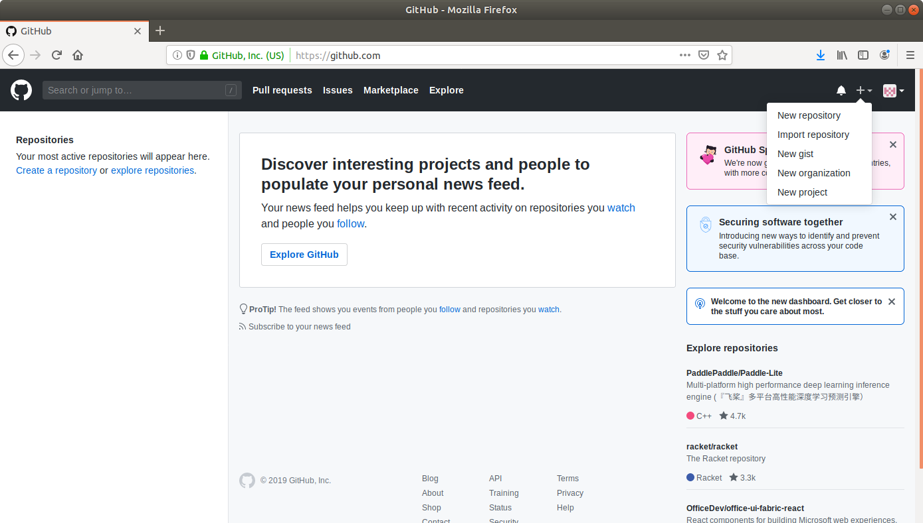

- Fill the required fields in the create repository form.
- Click on the Create Repository button.
- Click on the Clone or download button and copy the URL.
- Go to ​start.​spring.​io/​
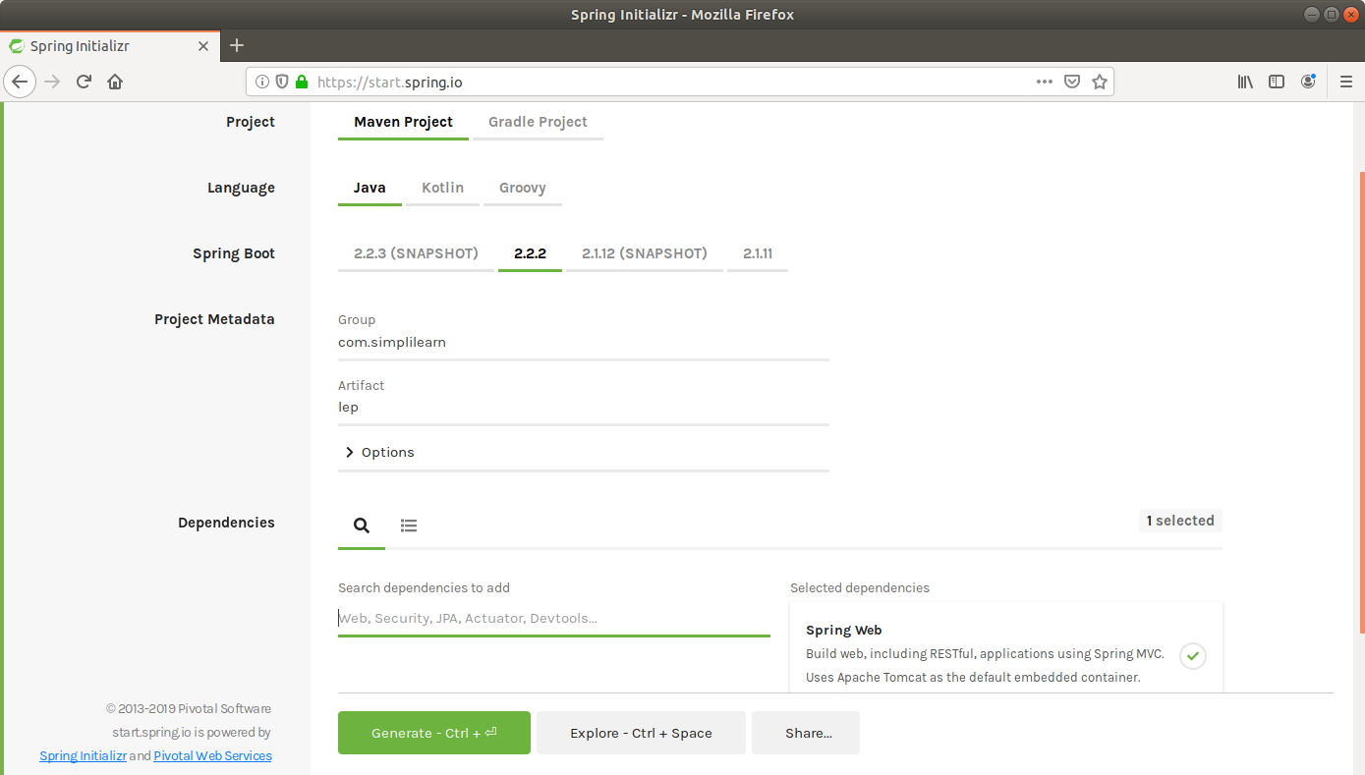
- Select Maven as the project type.
- Fill Group and Artifact with appropriate values. For example, com.simplilearn and Calculator1.
- Add Web (Spring Web) to Dependencies.
- Select Packaging as: jar
- Select Java: 8
- Click on Generate Project.
- The generated skeleton project should be downloaded as a zip file.
- Open the terminal and navigate to an appropriate location.
- Run git clone [URL] to clone the repository.
- Unzip the downloaded spring boot project to the cloned repository.
- (cd Downloads
unzip Calculator1.zip)
Copy the contents of Calculator1 folder present in downloads and paste it into your repository folder)
- Commit the changes to the remote SCM.
- Run git add .
- Run git commit -m “Add logic and test”
- Run git push -u origin master

Step 5.3.2: Creating and committing a Jenkinsfile
- Navigate to the root directory where the pom.xml is.
- Open a new text file and add the following script to it.
pipeline {
agent any
stages {
stage("Compile") {
steps {
sh "mvn compile"
}
}
stage("Unit test") {
steps {
sh "mvn test"
}
}
}
}

- Save the file as Jenkinsfile with no extension.
- Commit the changes to the remote SCM.
- Run git add .
- Run git commit -m “Jenkinsfile”
- Run git push -u origin master
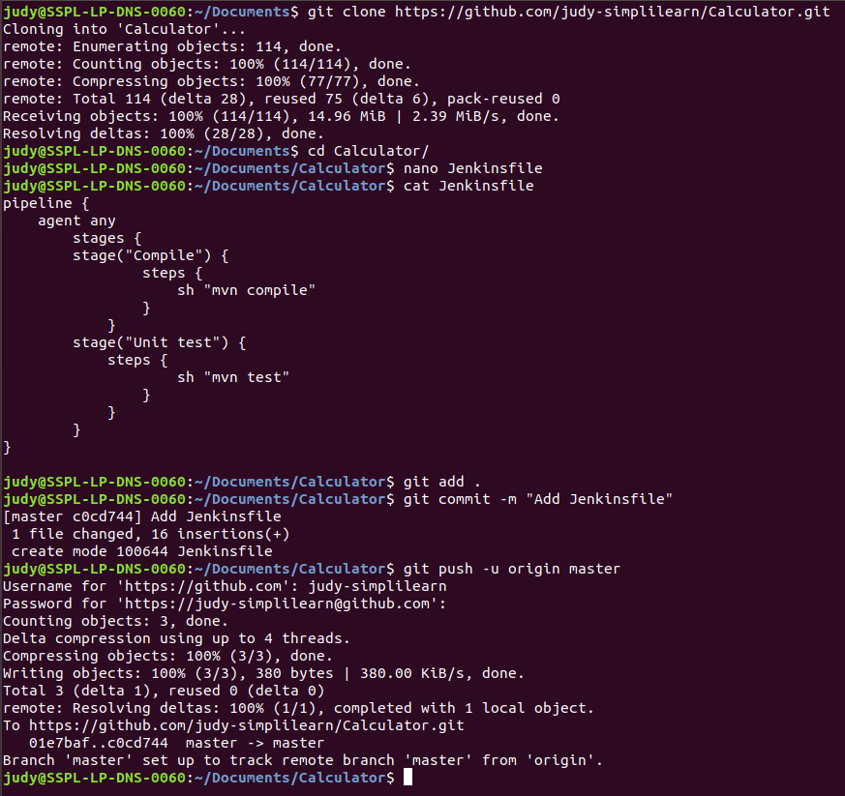
Step 5.3.3: Creating a Pipeline
- Go to Jenkins dashboard.
- Click on New Item.
- Enter a name for your build job.
- Select Pipeline as the build job type.
- Click OK.
- On the configuration page, scroll down to the Pipeline section.
- Change Definition from Pipeline script to Pipeline script from SCM.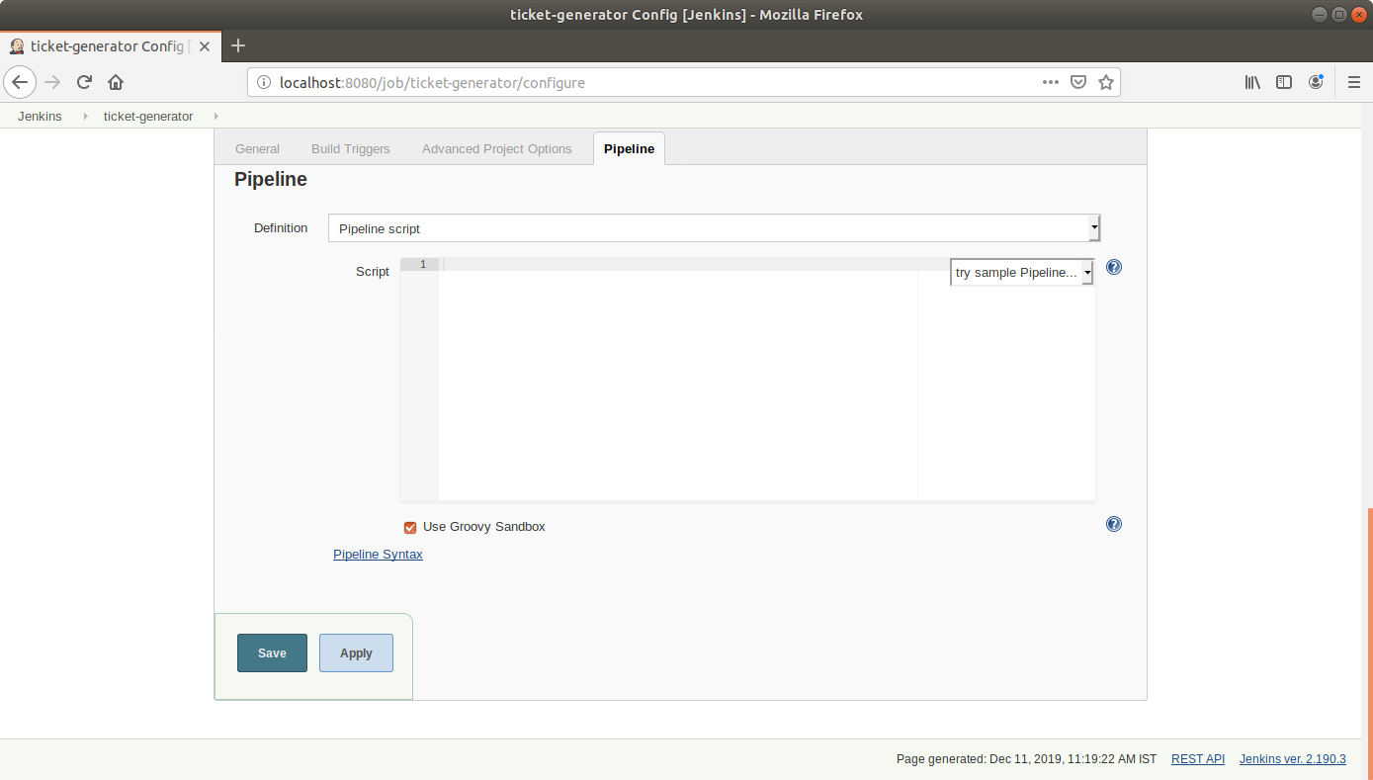
- Select Git in SCM.
- Add the repository URL.
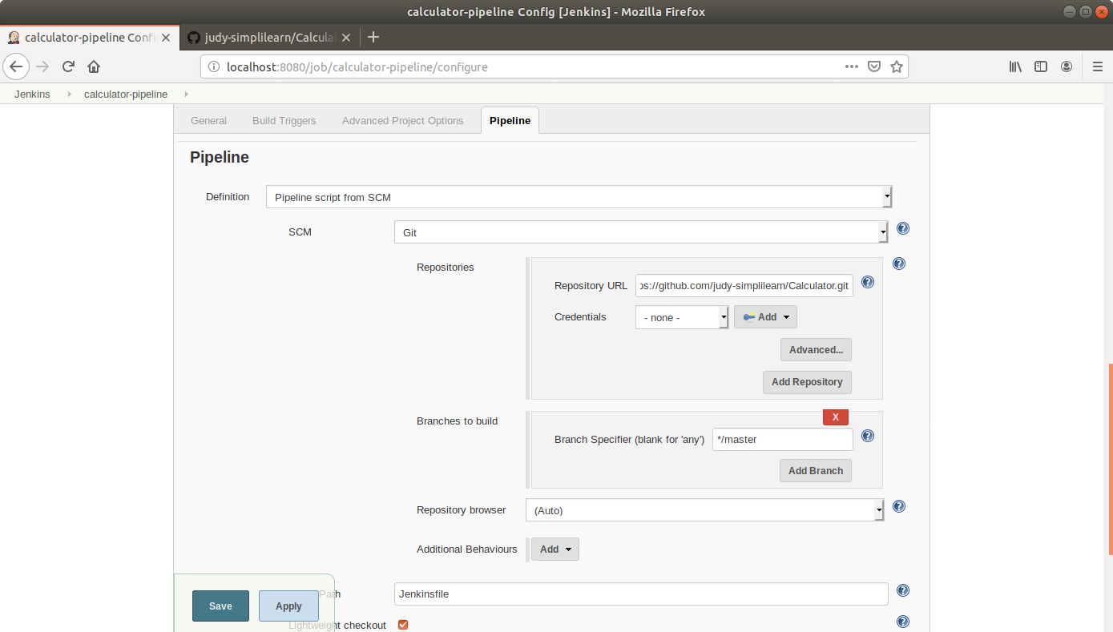
- Click Save.
- Click on Build Now in the project window.
- Jenkins will now build your pipeline and output the logs.
